ASSIGNMENT 4

Q1
import "dart:io";

void main() {
var ft = ["Ahmed", "Bilal", "Muhammad", "Owais", "Muhammad", "Ali", "Ahmed"];
var tf = ft.toSet().toList();
print(tf);
}
Ans
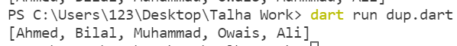
Q2

Ans

Q3
import "dart:io";
void main() {
stdout.write("Enter the Number: ");
int ft = int.parse(stdin.readLineSync()!);
if (ft % 2 == 0) {
print("Number is Even ");
} else if (ft % 2 != 0) {
print("Number is Prime ");
} else {
print("You Cannot Enter the Number ");
}
}
Ans

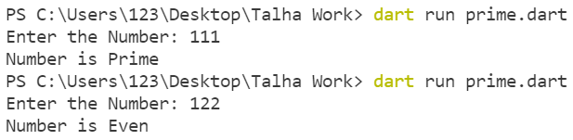

Q4
import "dart:io";

void main() {
for (int a = 7; a <= 105; a=a+7) {
print(a);
}
}
Ans
14
21
28
35
42
49
56
63
70
77
84
91
98
105

Q5

import "dart:io";

void main() {
List<dynamic> fruits = ["apple", "banana", "mango", "orange", "strawberry"];
for (var i in fruits) {
print(i);
}
Ans
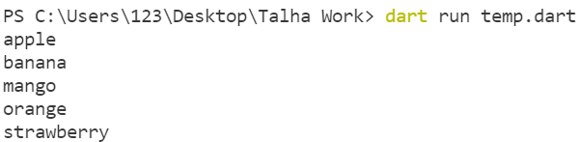

Q6
import "dart:io";

void main() {

for (int a = 5; a <= 100; a=a+5) {
print(a);
}}
Ans
5
10
15
20
25
30
35
40
45
50
55
60
65
70
75
80
85
90
95
100
Q7

import "dart:io";
void main() {
num Cel = num.parse(stdin.readLineSync()!);
num Far = (9 / 5 * Cel) + 32;
print("$Far NNoC is NNoF");
num FT = Far;
num Cl = 5 / 9 * (FT - 32);
print("$Cl NNoC is NNoF");
}
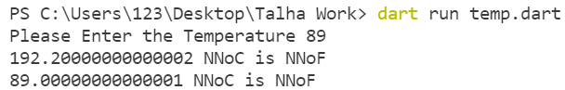

Q8

import "dart:io";
import "dart:math";

void main() {
stdout.write("Enter First Number: " "");
int ft = int.parse(stdin.readLineSync()!);
stdout.write("Enter Second Number: " "");
int tf = int.parse(stdin.readLineSync()!);
stdout.write("Enter the Operator: " "");
var ai = stdin.readLineSync();
if (ai == '*') {
print(ft * tf);
}
else if (ai == "+") {
print(ft + tf);
}
else if (ai == "-") {
print(ft - tf);
}
else if (ai == "/") {
print(ft / tf);
}
else if (ai == "%") {
print(ft % tf);
}
Ans
PS C:\Users\123\Desktop\Talha Work> dart run temp.dart
Enter First Number: 67
Enter Second Number: 87
Enter the Operator: /
0.7701149425287356
PS C:\Users\123\Desktop\Talha Work> dart run temp.dart
Enter First Number: 67
Enter Second Number: 87
Enter the Operator: *
5829
PS C:\Users\123\Desktop\Talha Work> dart run temp.dart
Enter First Number: 67
Enter Second Number: 87
Enter the Operator: -
-20
PS C:\Users\123\Desktop\Talha Work> dart run temp.dart
Enter First Number: 67
Enter Second Number: 87
Enter the Operator: +
154
PS C:\Users\123\Desktop\Talha Work> dart run temp.dart
Enter First Number: 67
Enter Second Number: 87
Enter the Operator: %
67
Q9
import "dart:io";
void main() {
stdout.write("Enter the Character: " " ");
var aa = stdin.readLineSync();
List<dynamic> ia = ["a", "e", "i", "o", "u"];
for (var i in ia) {
if (i == aa) {
print("vowel");
break;
} else {
print("Not Vowel");
break;
}
}
print(ia.contains(aa));
}

Ans
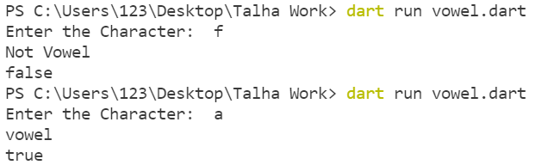
Q10
import "dart:io";

void main() {
String f= "natsikaP nawaJ";
print(f.split("").reversed.join());

}
Ans

Q13
import "dart:io";
void main() {
List<int> ft = [11, 22, 44, 9, 55, 99, 45, 5];
var tf = ft.reduce(min);
var ai = ft.reduce(max);
print(ai);
print(tf);
}
